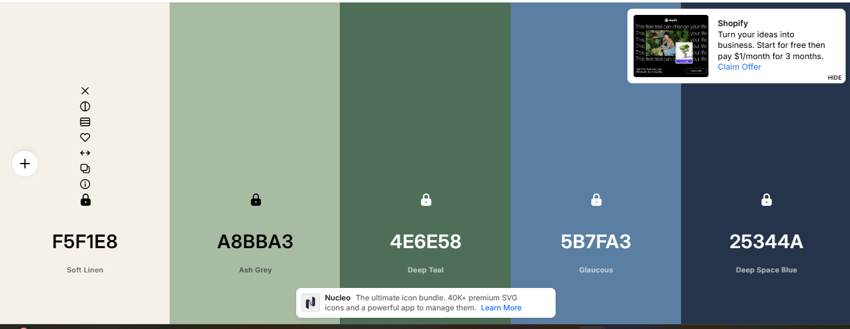
Colors:

#F5F1E8
#A8BBA3
#4E6E58
#5B7FA3
#25344A

Fonts:

Georgia
Arial
Verdana

Logo:


